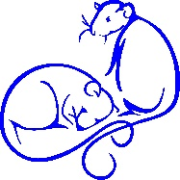
Rattie World O’ Comfort
Questionnaire for Memory Charms
These charms are made with love from the footprints of your heart pet.
You can either supply is with a print or get a kit to hold on to until that time when it is needed. Once the print is done and baked in the kit then use the return envelope and tin packed well in the tin to protect it to return it safely to us. Once the charm of your choice is made both the clay print and the charm will be shipped safely to you. Please return this completed questionnaire to mdkarr@rattieworldocomfort.com.
Questionnaire –
- Size of charm
  - ¾” tall – best for necklaces
  - 1” tall – best for bracelets or multiple charms
- How will it be used?
  - Necklace charm – one hole
  - Multi-charm necklace – two holes per charm
  - Bracelet – two holes per charm
  - Multi-charm bracelet
- Shape of the charm
  - Heart – for necklaces only
  - Circle – best for one holed charms
  - Oval – best for two holed charms
- Comments/Ideas of what you would like

Charges for the charms are based on the weight of the charm. 5 grams of sterling will cost approximately $40.

Examples –

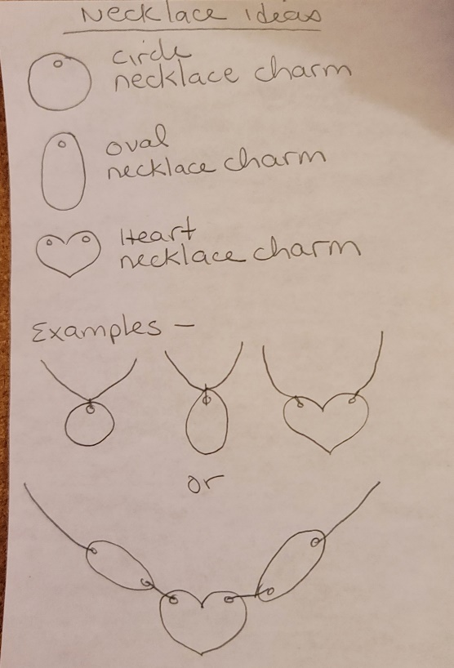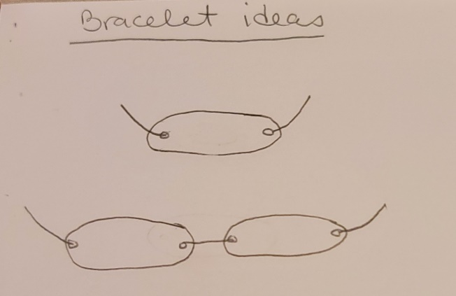
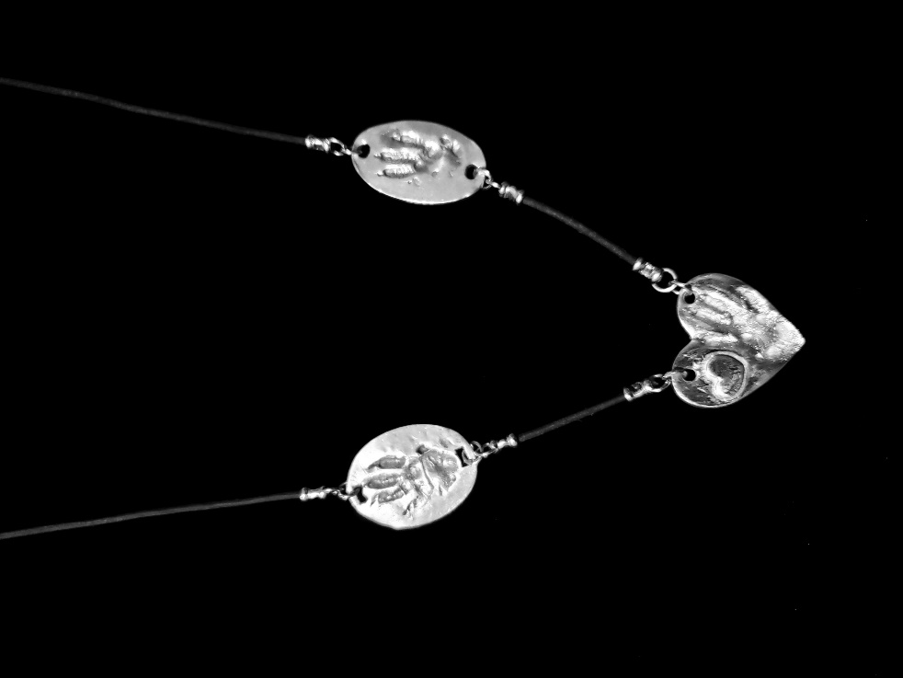 The heart has an optional added heart on it.
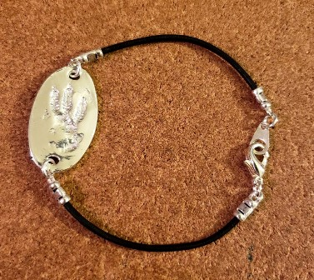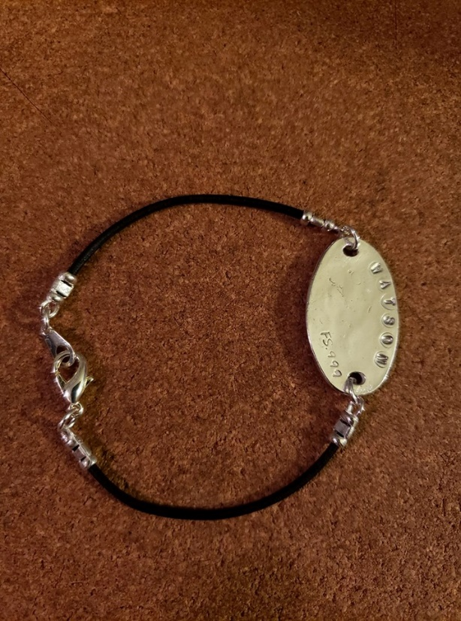
Front of the charm Back of the charm with optional stamped name
The clasps and circles are sterling silver plated.

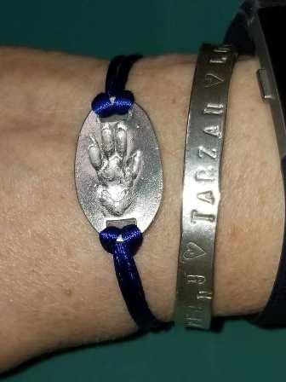 This charm can come alone, and your craft talent can create a beautiful
Bracelet piece for it.

